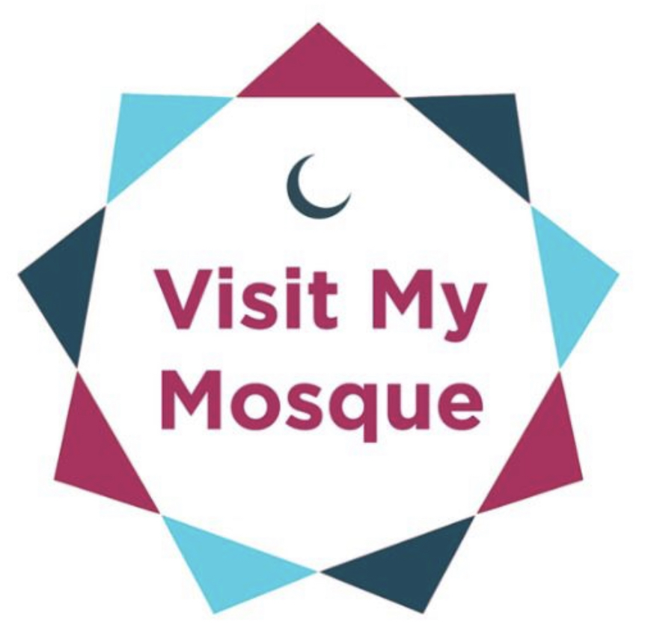

PRESS RELEASE
[Insert Date]
Sample Press Release

[Mosque Name] Announces return of popular Visit my Mosque open day

The [Insert Mosque Name] has announced that it will be hosting a community open day on [insert date]. Part of the national Visit My Mosque Day, [insert mosque name] is inviting locals of all faiths and none to explore the Mosque, learn about its history and significance to Muslim life, and meet those who worship there.

The day will feature tours, refreshments, children’s activities, a chance to observe prayer in the mosque and learn more about the Islamic faith. The open day is an important event of coming together. Mayor [Name Surname] will be attending, as well as representatives from religious groups, local police, schools and community groups.

President of [mosque name], said: “We are delighted at the level of interest in this event. We look forward to welcoming our friends and neighbours after such a difficult time; catching up over tea and snacks and in the spirit of dialogue and friendship, giving them an insight into the lives of Muslims and what goes on in the mosque.”

Cllr [Name Surname] of [Area] Borough Council said: “I know first hand all the good work that the Mosque has been for communities in [insert area] as well as the rich spiritual life which it hosts week in, week out. I am looking forward to the event which I hope will help bring people together and build bridges between communities.”

Ends.

Notes to editors:

1. For further information contact [Name Surname], Director of [Insert Mosque] on [Email Address] or on [Number].
2. [Insert background info on your mosque]
3. #VisitMyMosque Day is a national event which started in February 2015, where mosques across the UK hold open days, welcoming in their local neighbours in the spirit of friendship, and sharing tea and cakes alongside an insight into the day-to-day goings on of a busy Muslim centre of worship. This year on the weekend of the [date of event] will see over 250 mosques simultaneously hosting an open day.

